Horse Camp at Summerfield!
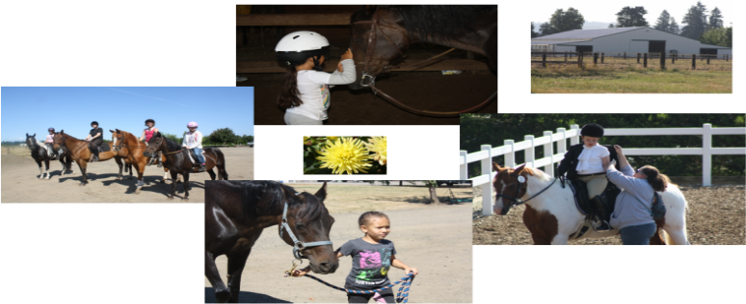
What??? During your week at horse camp you can look forward to….
- Having fun with horses and learning from 2 licensed school teachers. Both have 10+ years experience and Kelsi is a dressage trainer as well as 4-H leader and has been teaching horses and kids for over 15 years.
- Recognizing basic breeds, colors, and parts of the horse as well as components of tack, everyday we will be keeping an interactive journal that the kids will get to take home with them at the end of the week. We will also be doing fun “horsey” crafts each day.
- Identify what is involved in having a horse of your own by getting to incorporate all aspects of horse care including bathing, grooming, tacking up and untacking, leading, and of course riding!
- Having 2 lessons each day at camp, so spending lots of time around horses!
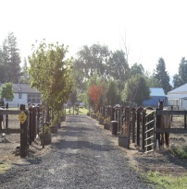
When??? Monday July 13th- Friday July 17th (8:00-12:00)
Cost??? $250 for the week
Where??? Summerfield Equestrian Center
6995 SW Straughan Rd. Hillsboro Or 97123
What do I Bring??? Boots, long pants, helmet (bike works), water
Sign me up… Return this portion of the form to Kelsi or mail it to the address above. Please make check payable to Kelsi Burkhardt.
Call: Kelsi at 503-799-8356 or email: kelsiburk14@gmail.com for questions
Name: ______________________________ Age: ______ School: _________________
Contact info: _________________________ experience: ____________________________
Parent I should contact if case of emergency: _________________________________
Their number while you are at camp: _________________________________________
*** On Friday we will be hosting a horse show to showcase to parents what we have learned throughout the week! *** Also, snacks will be provided everyday throughout the week

